LIVERPOOL CITY REGION

BLUE BADGE TOURIST GUIDE TRAINING COURSE

2023-2024

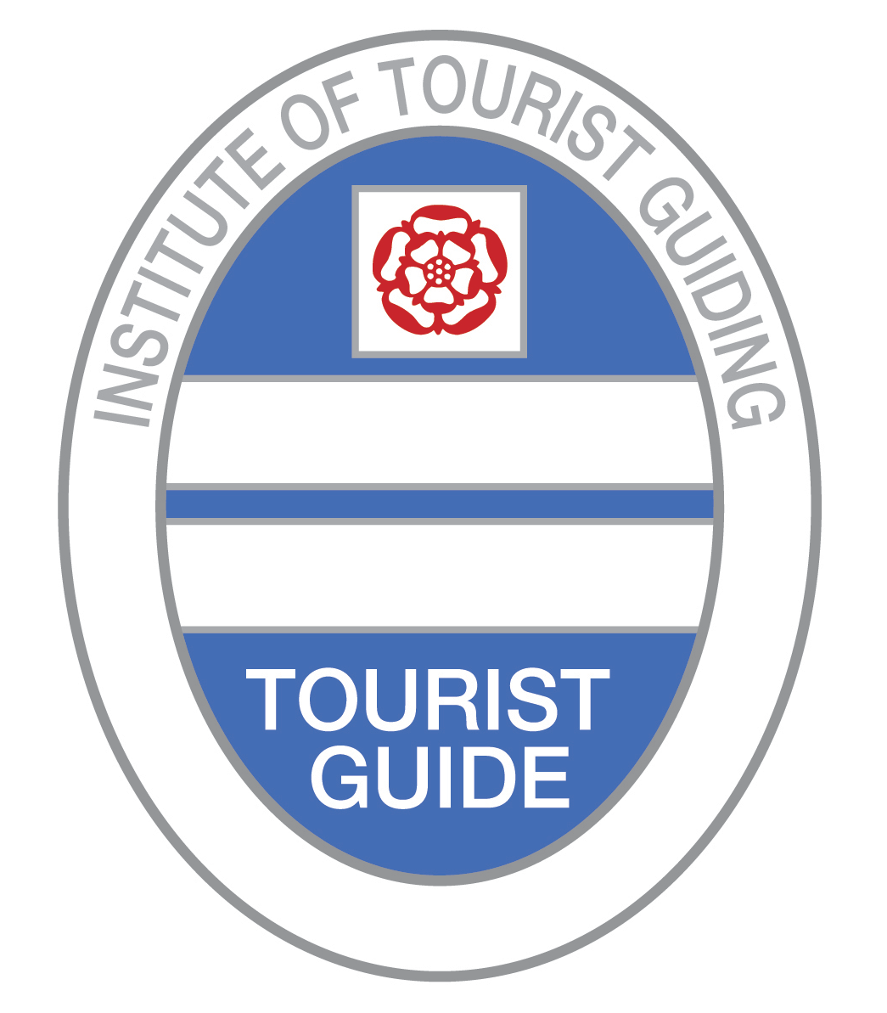

PROSPECTUS

Course Director:
Peter J. Colyer, BA(Hons), MEd, MA, PGCE, MITG
Institute of Tourist Guiding Guide Trainer

Course Provider:
The British Guild of Tourist Guides

Accredited by the Institute of Tourist Guiding

LCRTGA
LIVERPOOL CITY REGION
TOURIST GUIDES ASSOCIATION

Course email address to request an application form: liverpoolbbcourse@gmail.com

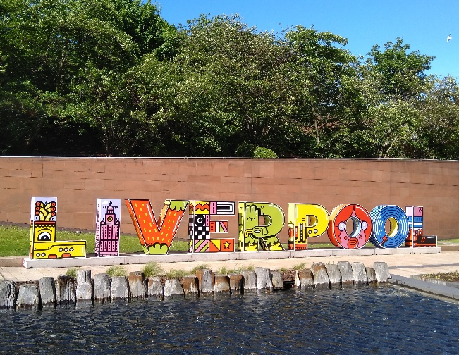 | What is a Tourist Guide?  The basic role of a tourist guide is to accompany visitors on scenic tours, and show them interesting places, explaining the significance of the site or object. However, there is a great deal more to the job than meets the eye. As well as being fully informed academically, the tourist guide needs to be welcoming, and enjoy working with people from many countries and backgrounds. Whilst in their company, the guide also becomes a guardian and will alert visitors to safety issues, local customs, and engage in conversations. It is this rapport that makes the job so enjoyable.
Who becomes a Tourist Guide?  Anybody can become a guide, but we will be training to Institute of Tourist Guiding standards, and our aim is to create the “best guides.” The Blue Badge is an internationally recognized brand of excellence. Tourist Guiding appeals to many people. It is an excellent opportunity to use foreign language skills. If you ask around, you will find Tourist Guides with backgrounds in law, nursing, teaching, architecture, IT, the armed forces, local government administration, the police, the media, coach driving and museum management, etc. There is no ideal background. | 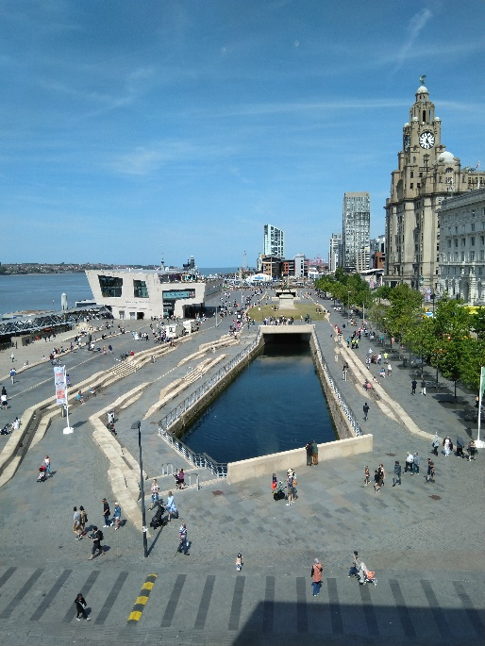
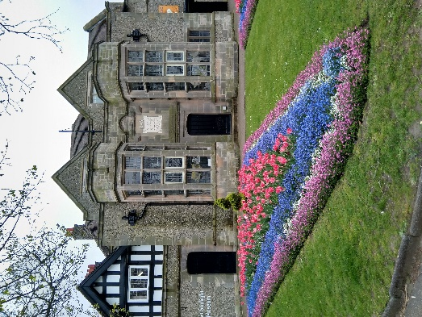 | The Liverpool City Region Tourist Guides Association (LCRTGA) embraces the concept of equal opportunities for all and looks forward to receiving applications from anyone who is attracted to the idea of becoming a tourist guide.  What area does the Liverpool City Region cover?  The Liverpool City Region Blue Badge qualification covers the City of Liverpool and the Merseyside boroughs of Wirral, Sefton, Knowsley, St Helens as well as Halton. Included in the qualification are two “Days Out” to Chester and North Wales.

What sort of income will I receive as a Tourist Guide?  Tourist guiding work is seasonal and most work is available in the summer months. Usually, tourist guides work freelance and are self-employed. The amount of guiding work is unpredictable and initially you are unlikely to earn enough in the Liverpool City Region to support a family. You will almost certainly need to have a second source of income. There are guides who combine guiding work with teaching, tutoring, acting, lecturing, journalism, tour managing, working at historic sites or in tour operations management. | 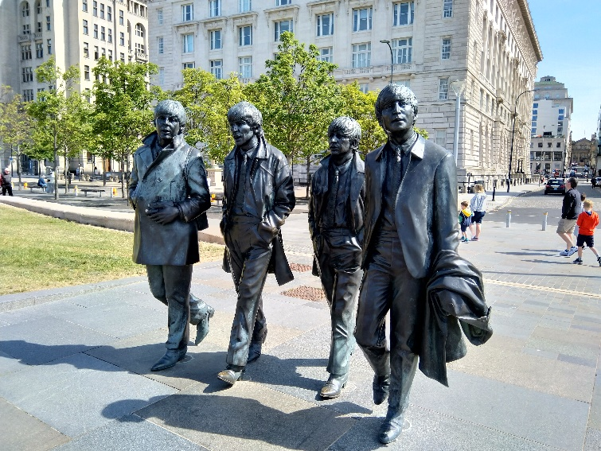
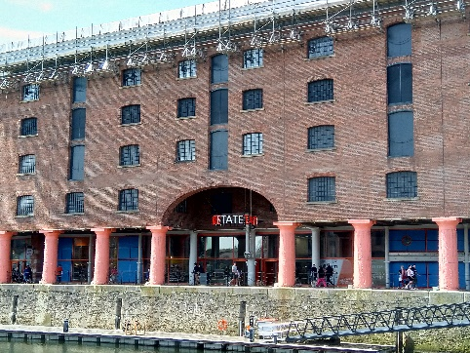 | How long will the Blue Badge training course last?  The course will extend over a full year, starting in late October 2023 and ending at the beginning of December 2024. Interviews for places will take place in the summer of 2023.
Course Aims  The course aims to train those with a fascination for the Liverpool City Region to become professionally qualified and registered Blue Badge Tourist Guides for the region. Registered tourist guides are qualified by examinations set and administered by the Institute of Tourist Guiding (ITG), which is the government-approved standard-setting and registration body for the tourist guiding sector in England, Northern Ireland and Jersey. Those students who are successful in these examinations will be awarded the Institute’s Blue Badge for “Liverpool City Region” and will be qualified to offer guided walks, site tours and coach tours to groups and individuals within the area of qualification. The Blue Badge is a symbol of this national qualification and provides recognised evidence of excellence in guiding skills. The course forms a foundation for continuing professional development in tourist guiding. | 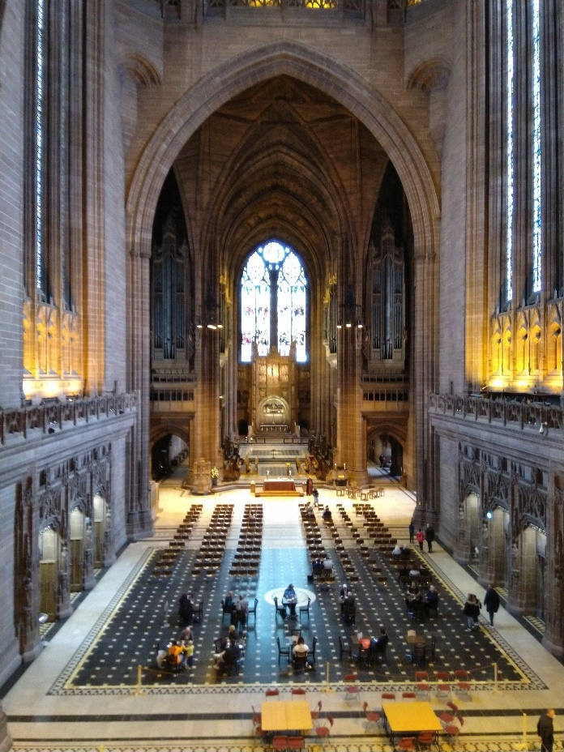

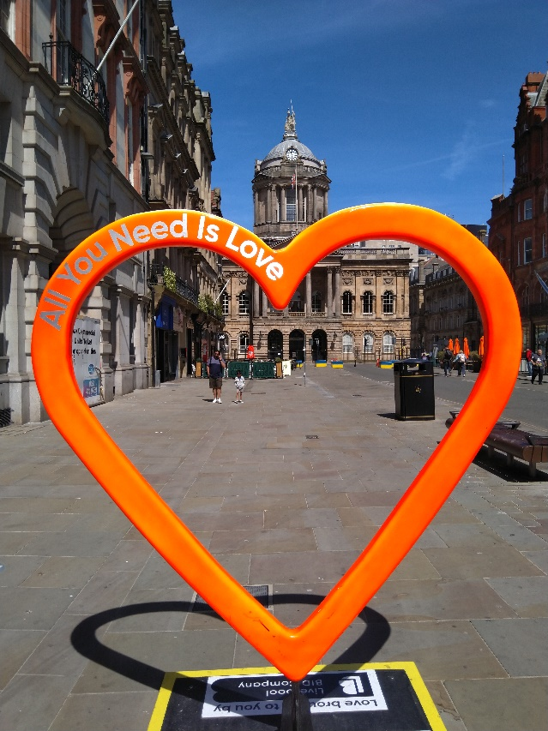 | Course Objectives  By the end of the course, students will have developed the following skills:  To select the most appropriate coach routes as well as routes and stopping places for walking tours and to lead tours of key sites within the area of qualification. These will be geared to meet the different requirements of groups and individuals.  Will have an appreciation of any special needs, expectations and interests of the visitors and take into consideration their health and safety, comfort, and wellbeing.  Present an effective tour commentary geared towards the target audience in terms of content, presentation, and duration. It will be clear, accurate, entertaining, and informative.  Demonstrate relevant management skills, including maintaining an appropriate time schedule and dealing with unexpected eventualities such as inclement weather, accidents and incidents during the tour, as well as late arrivals.  Demonstrate a range of effective and appropriate communication skills.
Course Content
There are two components to the training programme:
An in-depth knowledge of the Liverpool City Region and the surrounding area.
Guiding techniques: communication and presentation skills for guiding on foot, at sites and in moving vehicles.
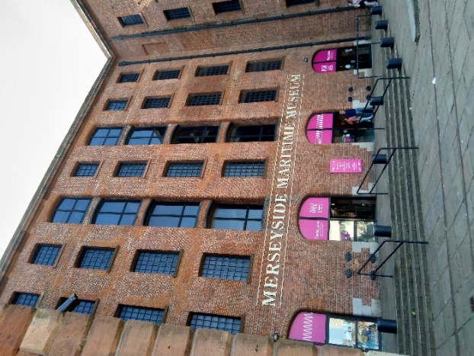 | Subjects to be covered include:  The Liverpool City Region in its geographical context and the geology of the area;  The history of the region, its development as a major port and its regeneration since 1981;  The architecture of the region;  Transport developments;  The region’s historic public parks.  The region’s sporting significance.  The cultural heritage including the legacy of The Beatles. Significant sites in the region, including the Liverpool Waterfront and the historic docks, National Museums Liverpool, William Brown Street, Hope Street and the two cathedrals, Birkenhead Priory and Hamilton Square, Port Sunlight Village and Thornton Hough, Wirral and New Brighton.
Course Structure

The course is designed to be part-time.

An introductory day on Saturday 30th September 2023

There will be weekend training days (Saturday and Sunday) on alternate weekends starting at the end of October 2023 and running until the start of December, then through January, February, March and April 2024, with a gap over the summer of 2024 and then resume through September, October and November 2024. Some lectures and workshops will be delivered during these weekend training sessions but they will be mostly practical sessions at sites, on walking tours and on coaches.

Most of the lectures for both the background knowledge examination and the required regional knowledge will be delivered on-line on Wednesday evenings every week throughout November 2023, January to April 2024 and September to November 2024. Most of these will be recorded so that students can replay them at their convenience.

- Lectures and classroom sessions. Lecturers and tutors will cover the topics listed in the Course Content on-line or by face-to-face lectures held in a variety of venues throughout the city.
- Student-led discussions and presentations on subjects related to the syllabus.
- Practical visits to sites in the Liverpool City Region. Trained guides and site experts will provide training on these visits; however, students will be expected to do a considerable amount of the guiding to practise guiding techniques and skills. This will be followed by collective and individual feedback.
- Communication seminar – a two-day seminar, concentrating on communication techniques and presentation skills for Tourist Guides.
- Health and safety, customer care and the widest possible access for all are stressed at all times.
- Private study. Although the course covers a wide range of topics and visits, students will be expected to do a considerable amount of private study.
- Project work and research for the practical sessions are an essential part of the course.
- Following the introductory day 30th September (during which guidance will be given on the personal research required), students will be required to undertake, in their own time, a full familiarisation of the Liverpool City Region.
- All students will be expected to research the subjects given in the syllabus fully over the course of the training period.
- We recommend that students carry out recces together during the period of summer study break and the course itself, as shared experiences provide more enjoyable visits, and the research work can be shared between students. This training does require commitment, but creates lasting memories of the discoveries made and the camaraderie experienced throughout.
- The break in December and over the summer months of 2024 are intended as study leave for reading and research, visits to places of interest and the completion of the Tour Planning Project.
- It is expected that students will attend, participate in, and commit themselves fully to the programme of study.

Please Note: students are expected to have regular access to a computer (desktop, laptop or tablet) and email, as course communications will be sent out electronically, and for participation in the on-line training sessions. This may be through a local library if necessary.

A Student Handbook containing the full syllabus and programme will be given to all students during the introductory session.

Part One – Saturday 30th September 2023 – 1-day introductory session

This will be followed by a break - for private home study and individual research

Part Two – End of October 2023 to April 2024

The training will be delivered during 14 weekends and 16 Wednesday evening on-line sessions. The Saturday and Sunday training days will generally run between 9 am and 5 pm, with individual student tutorials scheduled during the lunch break and after the afternoon session. Wednesday on-line sessions will run between 6 pm and 9 pm.

Weekend training days:
28 & 29 October
4 & 5, 18 & 19 November
2 & 3 December
6 & 7, 20 & 21, 27 January
3 & 4, 17 & 18, 24 & 25 February
2 & 3, 16 & 17 March
13 & 14, 27 & 28 April

Wednesday evening on-line sessions:
1, 8, 15, 22, 29 November
10, 17, 24, 31 January
7, 14, 21, 28 February
6, 13, 20 March

Part Three – Summer study break

Students will complete the tour-planning project during this period. Individual tutorials will be scheduled to support students with this. The project will be submitted at the end of August. Students will also be given a list of visits to make and recommended reading to enrich and consolidate their knowledge of the region and to prepare for the examinations at the end of the course.
Saturday 25 May- Tour Planning Project Briefing
Wednesday evening on-line sessions:
29 May & 5 June

Part Four – September to November 2024

The training will be delivered during 7 weekends and 8 Wednesday evening on-line sessions. The Saturday and Sunday training days will generally run between 9 am and 5 pm, with individual student tutorials scheduled during the lunch break and after the afternoon session. Wednesday on-line sessions will run between 6 pm and 9 pm.

Weekend training days:
7 & 8, 21 & 22 September
5 & 6, 19 & 20 October
2 & 3, 16 & 17, 30 November
1 December

Wednesday evening on-line sessions:
11, 18, 25 September
2 October
6, 13, 20, 27 November

The weekend sessions will combine lectures and talks about the Liverpool City Region and associated topics with the art of guiding with practical sessions on walks, at sites and on coaches.
Sessions on examination preparation will be held leading up to each set of examinations.

Final Assessment – anticipated dates

The examinations will be taken at relevant stages of the course.

- The Background Knowledge examination (Paper 1) is taken across the country in April 2024.
- The practical examination in a religious building will take place in May 2024.
- The practical examination in an art gallery or museum will take place in May 2024.
- The tour-planning project will be submitted at the end of August 2024*
- The practical walking tour examination will take place in January 2025.
- The practical coach guiding examination will take place in January 2025.
- The first regional examination paper (Paper 2) will take place in February 2025.
- The second regional examination paper (Paper 3) will take place in February 2025.

*A 3,000-word tour-planning project will be prepared by each student, based on a choice of three themes; this will be included in the examination assessments. The choices will be given out in May with a submission date at the end of August.

Successful applicants will be awarded the Liverpool City Region Blue Badge, certificate and will be issued with the Institute’s Registered Guide photo card at an award ceremony (date to be confirmed).

Cost
There are two cost elements:

1. Training Costs: The course fee will be £3550 payable on acceptance on the course. Staged payments can be negotiated. This cost includes tuition, admission and supervision on practical visits, and course learning materials. Also included is a two-day Communications Seminar on practical presentation skills for Tourist Guides, which will take place in February. Students will be given a year’s membership of the Liverpool History Society and membership of the Merseyside Civic Society. Excluded from these costs are personal transportation costs, overnight accommodation, guide books or literature specific to historical or cultural sites and attractions.

2. Institute of Tourist Guiding examination fees.
(a) These amount to £1568.
(b) If trainees already have an ITG Blue or Green Badge they could be exempt from the walking tour examination. Blue Badge guides could also be exempt from the Background Knowledge examination, the religious building examination, and the tour-planning project. In these cases, the examination fees will be less. Those trainees who already have an ITG Blue or Green Badge and have completed a Communications Seminar within the previous 5 years could be exempt from that.

After qualification as a Blue Badge Guide, students wishing to guide in a language other than their own mother tongue are encouraged to take examinations conducted by the Institute of Linguists on behalf of the Institute of Tourist Guiding, for which a separate fee is payable.

Application and Selection

Completed application forms should be sent by email to liverpoolbbcourse@gmail.com

- Interviews: Applicants will be asked to attend a background knowledge test and interview, including making a brief presentation of a site of their choice for no more than 3 minutes, without notes.
- Candidates offered a place on the course will be informed in writing following the interview.
- Candidates, of a minimum age of 18, will need to demonstrate an outgoing personality, smart appearance, good general knowledge, organisational ability, flexibility, a genuine interest in people, an enthusiasm for the Liverpool City Region and the motivation to develop their own business.
- Preference for places on the programme will be given to those demonstrating an ability to train to guide in a foreign language and to those living in the region.

The Guiding Profession

The Institute of Tourist Guiding (ITG)  This is the standard setting body, not only for Blue Badge guides but for the whole of the tourist guiding sector. It accredits courses which meet its standards and provides examinations at White, Green and Blue Badge Levels. Registration with the ITG signifies that a Guide has achieved an accepted level of professional competence. The ITG does not engage tourist guides but promotes its qualifications in general. Blue Badge Guides are listed on the Institute web site, which is available to users of guide services. | 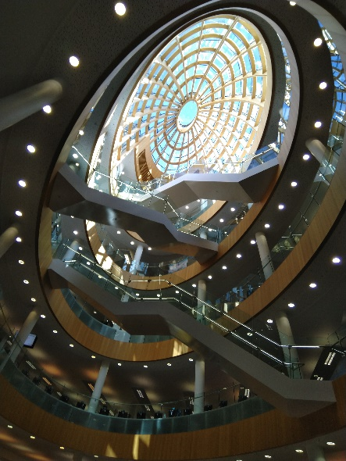
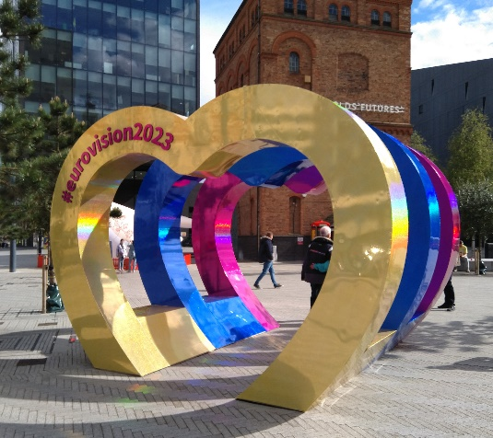 | The British Guild of Tourist Guides (BGTG)  This is the tourist guides’ national professional association. It provides training courses for tourist guides, including this one. It promotes badged guides within the tourism industry and the visitor economy. It provides badged guides with public liability and personal accident insurance and a programme of continuing professional development (CPD).
The Liverpool City Region Tourist Guide Association (LCRTGA)  This is the local organisation for qualified guides in the Liverpool City Region, run by a volunteer committee to represent and promote the interests of its members. The LCRTGA also provides a cohesive voice for guides working within the region with the Chair of the LCRTGA sitting on the UK Committee of the BGTG. | 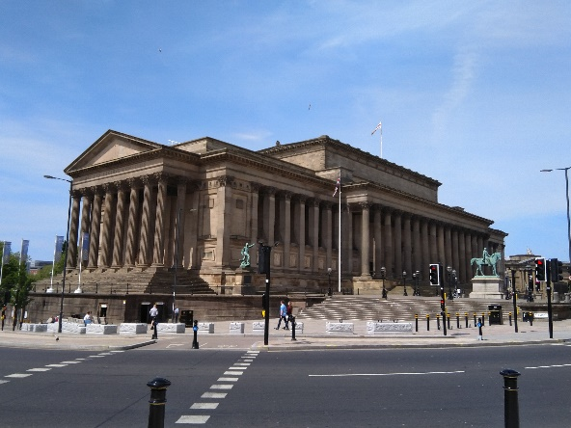
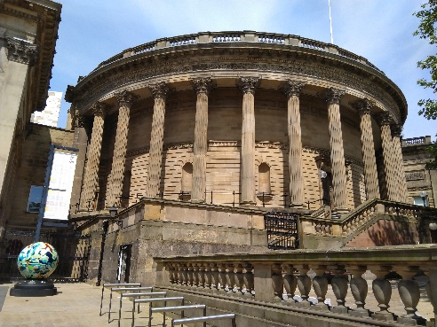 | The North West Tourist Guides Association (NWTGA)  The NWTGA exists to represent guides working in the North West of England regions of Chester, Liverpool, Manchester and Lancashire. It provides networking opportunities for Guides in the NW areas and the sharing of Continuing Professional Development skills.

(All photographs are the copyright of Peter J. Colyer)

